**Midterm Team Project:**

**Sonoma County Department of Health Services Food**

**Facility inspection**

Group 1:

* Amey Parange
* Ashwini Khedkar
* Asawari Kadam
* Neha Bhutkar

**Table of Contents**

1. **Introduction**
   * Project Overview
   * Data Source Description
2. **Data Profiling and Understanding**
   * Schema Examination
   * Content Assessment
   * Data Quality Assessment
3. **Business Requirements**
   * Creating Violation Category
   * Calculating Violation Score
   * Determining Inspection Results
   * Handling Location Field
4. **Data Preparation (Part 1)**
   * Data Retrieval
   * Data Format Selection
   * Data Loading into Stage Table
   * Staging Guidelines and Audit Columns
   * Data Profiling Outcomes
   * Data Cleansing Methods
5. **Dimensional Data Modeling (Part 2)**
   * Identification of Facts and Dimensions
   * Grain Definition
   * Handling Inspection Codes
   * Surrogate Keys, Relationships, and Associations
   * Appropriate Data Types
   * Date Dimension and Format
   * ER Studio/Navicat Modeling
   * DDL Script Generation
6. **Data Loading (Part 3)**
   * Data Preparation Workflow
   * Talend Jobs Execution
   * Business Logic Documentation
   * Repository Usage
   * Meaningful Naming Conventions
   * Execution Documentation

**Project Overview:**

The Food Inspections Assignment involves the analysis of food inspection data from the Sonoma County Department of Health Services. This documentation provides a comprehensive overview of the project's key components, data sources, and deliverables.

**Step 1: Discussed the Schema and Content of the data provided.**

* Understood the layout of tables, fields, and the relationships between different data elements. It helped us in understanding how the data is organized.

**Step 2: Data Profiling in Alteryx:**

**Title**: Sonoma County Department of Health Services Food Facility Inspection Dataset

**Description of Dataset:**

The food inspection dataset provided by Sonoma County

**Aim of the Assignment:**

The objective of this assignment is to examine the dataset and document any identified issues, including but not limited to missing data, data discrepancies, and inconsistencies.

**Alteryx Profiling workflow screenshot:**

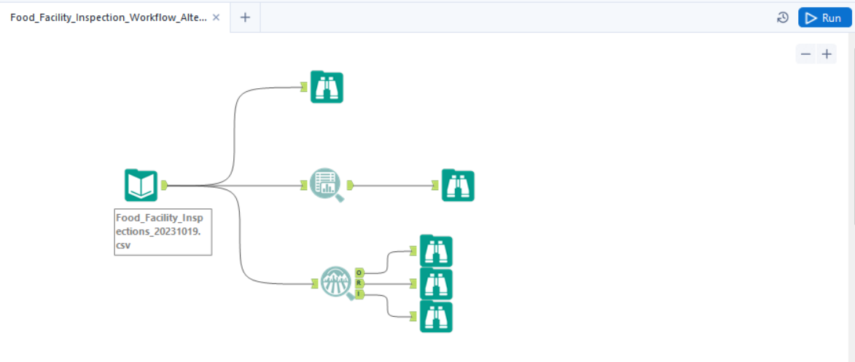

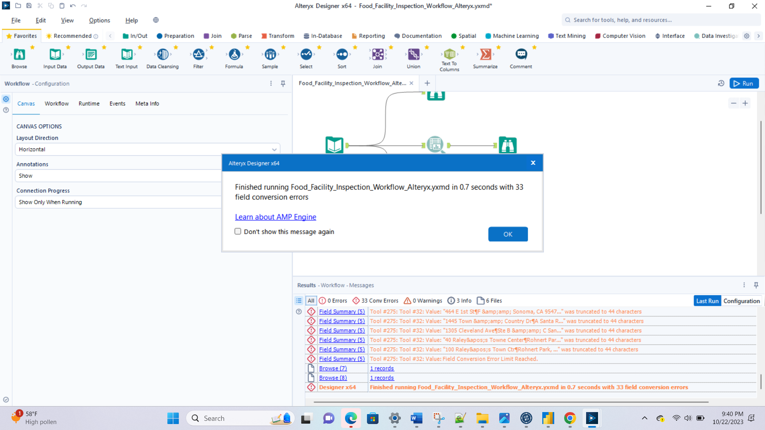

**Observation:**

|  |  |  |  |  |  |  |  |
| --- | --- | --- | --- | --- | --- | --- | --- |
| Name | Datatype | % missing | Unique values | Null values | Observation | Min Value | Max Value |
| BusinessID | V_String | 0% | 14.04% | 0.00% | This column has a relatively high percentage of unique values (14.04%), indicating a diverse range of business IDs. There are no missing values. | 1 | 34 |
| Name | V_String | 0% | 12.05% | 0.00% | The 'Name' column also exhibits a significant percentage of unique values (12.05%) without any missing values. | 1 | 196 |
| Address | V_String | 0% | 10.93% | 0.00% | 'Address' has a notable percentage of unique values (10.93%) and no missing values. | 1 | 83 |
| City | V_String | 0% | 0.17% | 0.00% | The 'City' column shows a low percentage of unique values (0.17%), suggesting some repetition of city names. There are no missing values. | 1 | 9897 |
| State | V_String | 0% | 0.01% | 0.00% | 'State' has an extremely low percentage of unique values (0.01%), indicating a limited set of state names. No missing values are present. | 2 | 25310 |
| Zip Code | V_String | 0% | 0.30% | 0.00% | Like 'State,' the 'Zip Code' column also has a very low percentage of unique values (0.30%) with no missing values. | 2 | 2569 |
| PhoneNumber | V_String | 17.01564% | 13.25% | 17.02% | This column has a high percentage of missing values (17.02%) and a moderate percentage of unique values (13.25%). It also contains a significant number of null values. | 1 | 4307 |
| Inspection Id | V_String | 0% | 0.00% | 0.00% | 'Inspection Id' has no missing or null values, and each value is unique. | 1 | 1 |
| Date | V_String | 1.18520% | 8.77% | 0.01% | The 'Date' column has a relatively low percentage of missing values but a moderate percentage of unique values (8.77%). There is also a small percentage of null values. | 1 | 45 |
| InspectionType | V_String | 0.01% | 0.01% | 0.01% | 'InspectionType' has a very low percentage of missing, unique, and null values, suggesting a limited variation in the inspection types. | 3 | 22644 |
| ViolationCodes | V_String | 39.83091% | 21.22% | 39.83% | This column has a high percentage of missing and null values (39.83%) and a moderate percentage of unique values (21.22%). It may require cleaning or handling of missing data. | 1 | 10,082 |
| ViolationDescriptions | V_String | 40.02844% | 23.85% | 40.03% | Similar to 'ViolationCodes,' this column also has a high percentage of missing and null values (40.03%) and a moderate percentage of unique values (23.85%). Data cleaning may be needed. | 1 | 10,132 |
| Location | V_String | 1.18520% | 12.13% | 0.01% | 'Location' has a relatively low percentage of missing values and a moderate percentage of unique values (12.13%). However, there is a small percentage of null values. | 1 | 88 |

In summary, the provided table contains a mix of columns with varying characteristics:

* Several columns like 'BusinessID,' 'Name,' 'Address,' 'City,' 'State,' and 'Zip Code' have low to moderate uniqueness but no missing data.
* 'PhoneNumber' is marked by a high percentage of missing data (17.02%) and moderate uniqueness (13.25%), with many null values. It also has discrepancy in format. As example, some columns have extension +1 while some have 1.
* 'Date' exhibits a low percentage of missing data (1.18520%) and moderate uniqueness, while 'InspectionType' has low percentages of missing, unique, and null values.
* 'ViolationCodes' and 'ViolationDescriptions' columns have high percentages of missing data (39.83% and 40.03%, respectively) and moderate uniqueness, necessitating data cleansing and normalization.
* The 'Location' column exhibits a moderate level of uniqueness and a relatively low percentage of missing data (1.18520%). However, it is worth noting that this column initially contained multiline values, necessitating the handling of newline characters (i.e., '\n'). To enhance its utility for data visualization purposes, we performed additional processing to derive latitude and longitude information from the 'Location' column, thereby simplifying its structure.

For further analysis, attention is required to address missing data in 'PhoneNumber,' 'ViolationCodes,' and 'ViolationDescriptions.' Exploring potential correlations among columns with similar missing data percentages, such as 'ViolationCodes' and 'ViolationDescriptions,' could yield valuable insights.

**Plan of Action:**

* Designing of ER Diagram to identify dimensions and facts based on the profiling done in Alteryx as below:

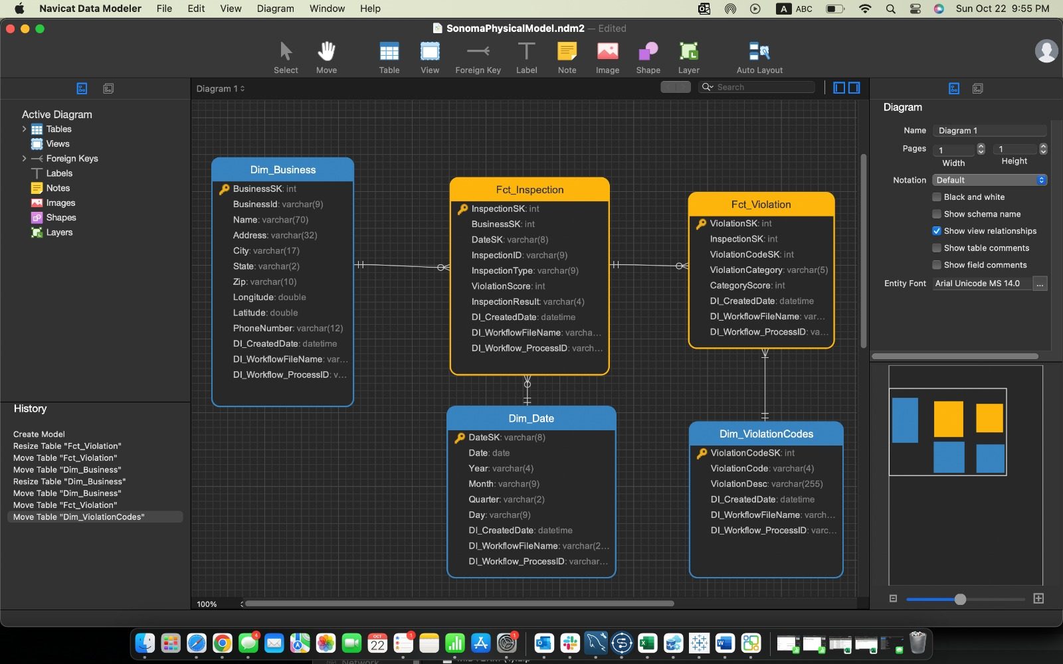

* For inspection event, the **grain** is defined by “day”.
* Now handling anomalies:
* Handled multiline values in the delimited file by defining text enclosure as “\’
* Before loading data to stage table we handled discrepancies in following fields   
  PhoneNumber, removed +1 to maintain data consistency
* Creating latitude and longitude column from location column.
* Created DI_CreatedDate, DI_WorkflowFileName, DI_Workflow_ProcessID
* Post loading data into staging tables, into both MySQL and Azure SQL Server database, we designed workflow to load dimension tables.

Using TMap we loaded Dim_business with following columns from staging table:

`BusinessSK` int NOT NULL AUTO_INCREMENT,

`BusinessId` varchar(9) NOT NULL,

`Name` varchar(70) NULL,

`Address` varchar(32) NULL,

`City` varchar(17) NULL,

`State` varchar(2) NULL,

`Zip` varchar(10) NULL,

`Longitude` double NULL,

`Latitude` double NULL,

`PhoneNumber` varchar(12) NULL,

`DI_CreatedDate` datetime NULL,

`DI_WorkflowFileName` varchar(255) NULL,

`DI_Workflow_ProcessID` varchar(10) NULL,

Using TMap we loaded Dim_date with Date column from staging table and created new columns:

`DateSK` varchar(8) NOT NULL,

`Date` date NULL,

`Year` varchar(4) NULL,

`Month` varchar(9) NULL,

`Quarter` varchar(2) NULL,

`Day` varchar(9) NULL,

`DI_CreatedDate` datetime NULL,

`DI_WorkflowFileName` varchar(255) NULL,

`DI_Workflow_ProcessID` varchar(20) NULL

To handle, multiple inspection code we used 2 tNormalize to normalize ViolationCode and ViolationDescription and used tHashinput and tHashOutput component to merge data with unique matches.

CREATE TABLE `Dim_ViolationCodes` (

`ViolationCodeSK` int NOT NULL AUTO_INCREMENT,

`ViolationCode` varchar(4) NULL,

`ViolationDesc` varchar(255) NULL,

`DI_CreatedDate` datetime NULL,

`DI_WorkflowFileName` varchar(255) NULL,

`DI_Workflow_ProcessID` varchar(20) NULL,

Finally, we loaded Fct_inspection using stage table, Dim_business and Dim_date using tMap.

`InspectionSK` int NOT NULL AUTO_INCREMENT,

`BusinessSK` int NOT NULL,

`DateSK` varchar(8) NULL,

`InspectionID` varchar(9) NULL,

`InspectionType` varchar(9) NULL,

`ViolationScore` int NULL,

`InspectionResult` varchar(4) NULL,

`DI_CreatedDate` datetime NULL,

`DI_WorkflowFileName` varchar(255) NULL,

`DI_Workflow_ProcessID` varchar(20) NULL

We loaded Fct_violation using stage table, Dim_violationCodes using tMap. Then, created new columns ViolationsCategory using ViolationDescription field and ViolationScore which was calculated on the basis of violationCategory Column

CREATE TABLE `Fct_Violation` (

`ViolationSK` int NOT NULL AUTO_INCREMENT,

`InspectionSK` int NULL,

`ViolationCodeSK` int NULL,

`ViolationCategory` varchar(5) NULL,

`CategoryScore` int NULL,

`DI_CreatedDate` datetime NULL,

`DI_WorkflowFileName` varchar(255) NULL,

`DI_Workflow_ProcessID` varchar(20) NULL,

Finally, using Fct_violation table we calculated aggregated InspectionScore in Fct_inspection table. And on the basis of score we determined InpspctionResult column value.

**Talend Job workflow documentation**

**Workflow run**

* Workflow to load data into staging tables

MySQL - stg_food_inspections

Azure SQL Server - stg_azure_food_inspections

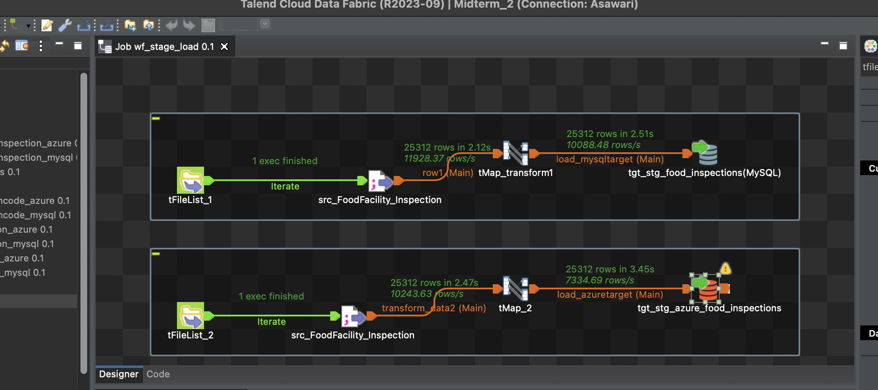

* Loading data to Dim_Business

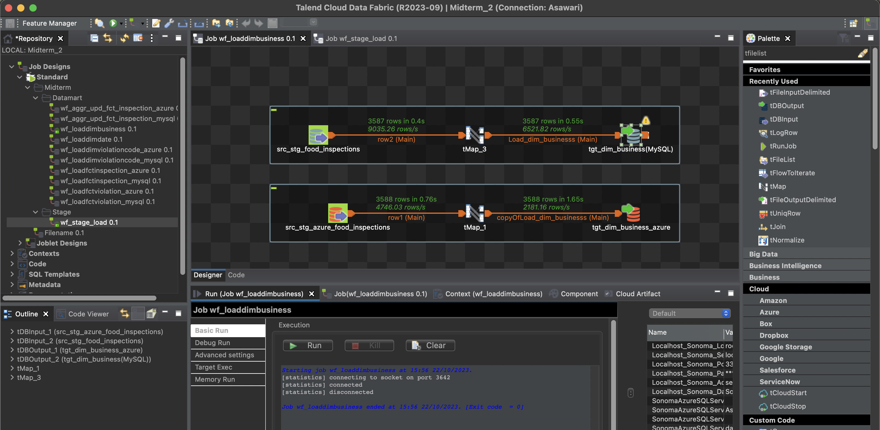

* Loading data to Dim_Date

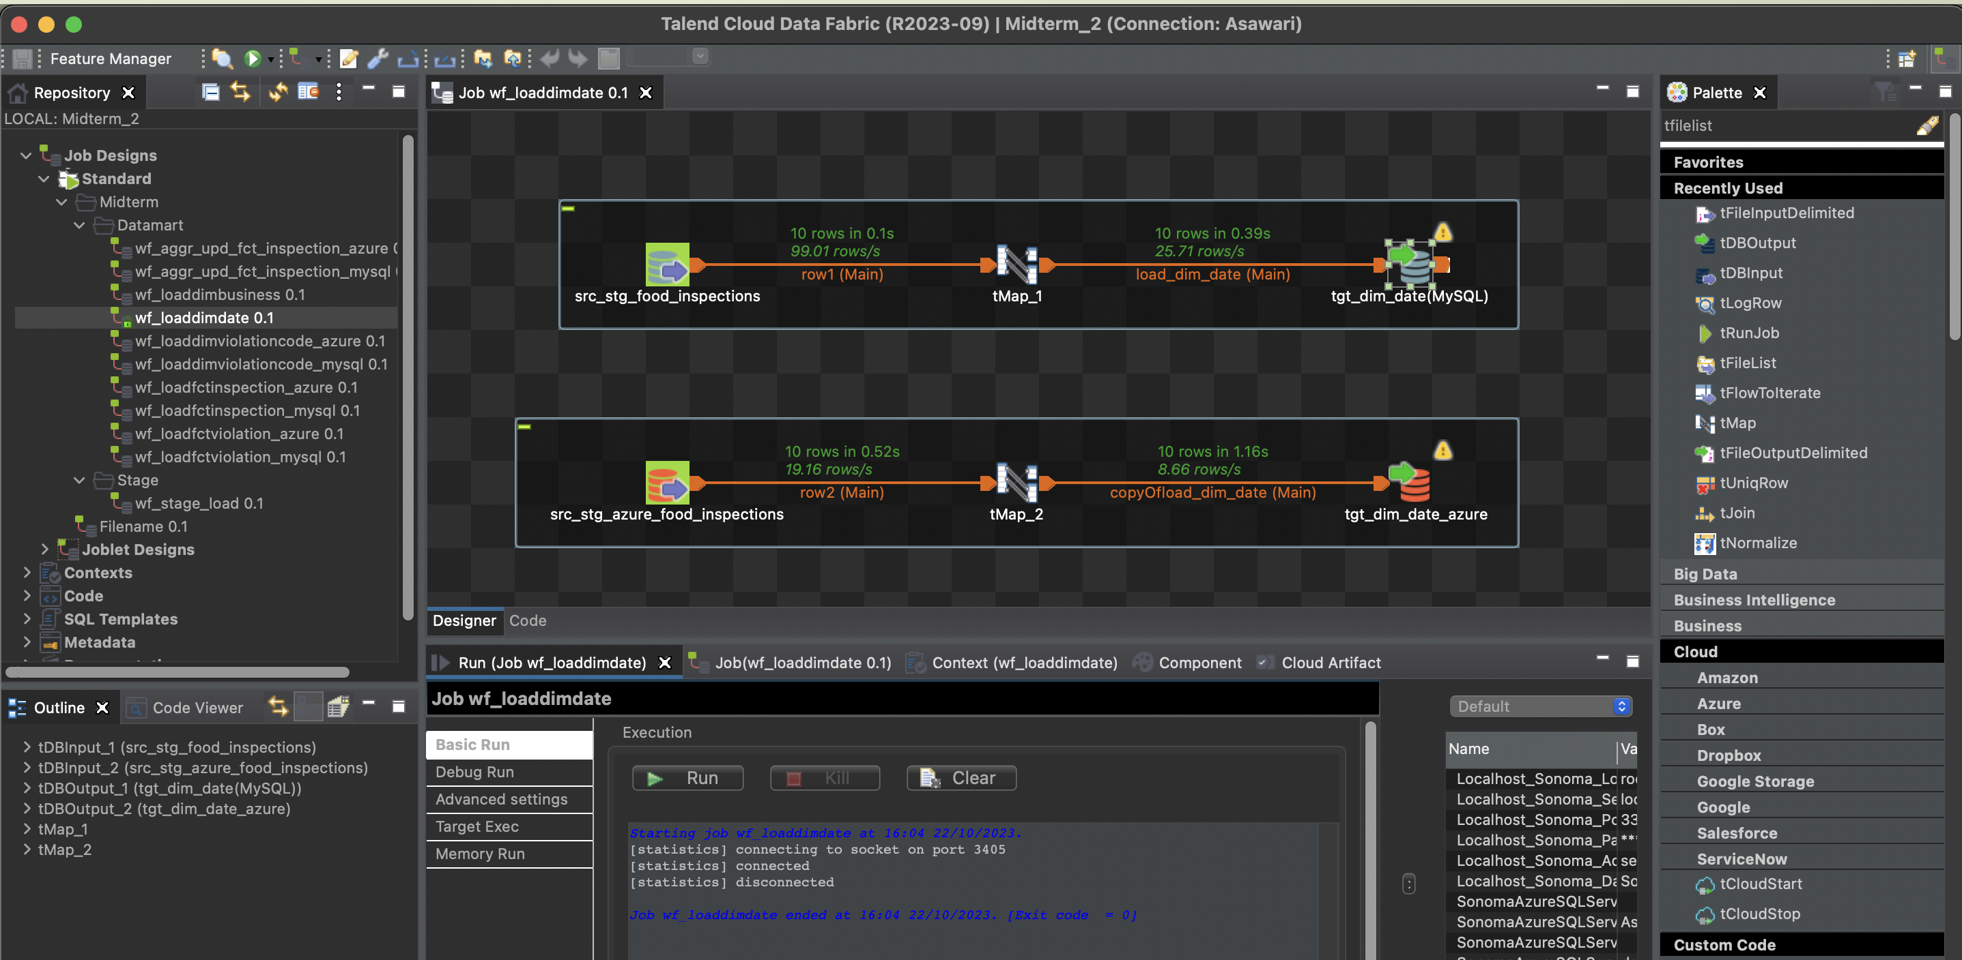

* Loading data to Dim_ViolationCodes

MySQL:

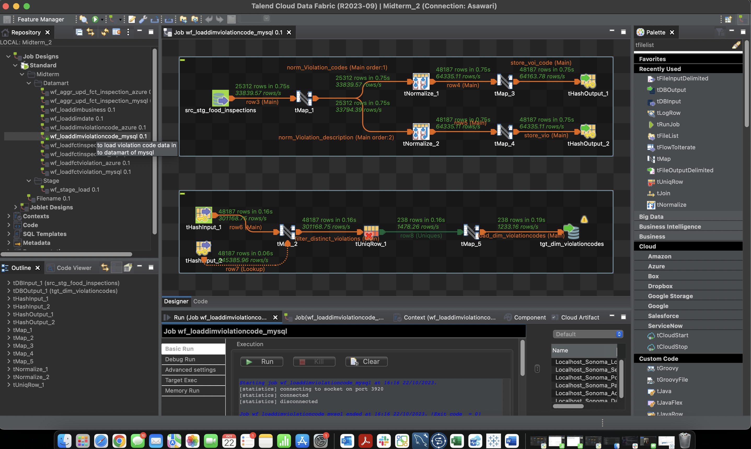

Azure Sql Server:

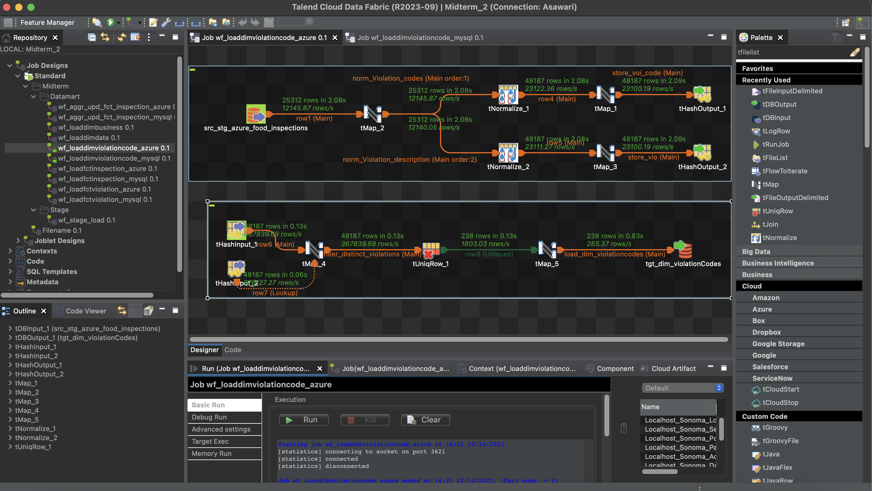

* Loading data to Fct_Inspection

MySQL:

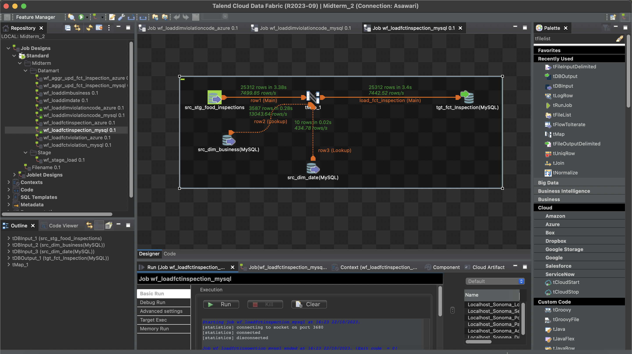

Azure SQL Server:

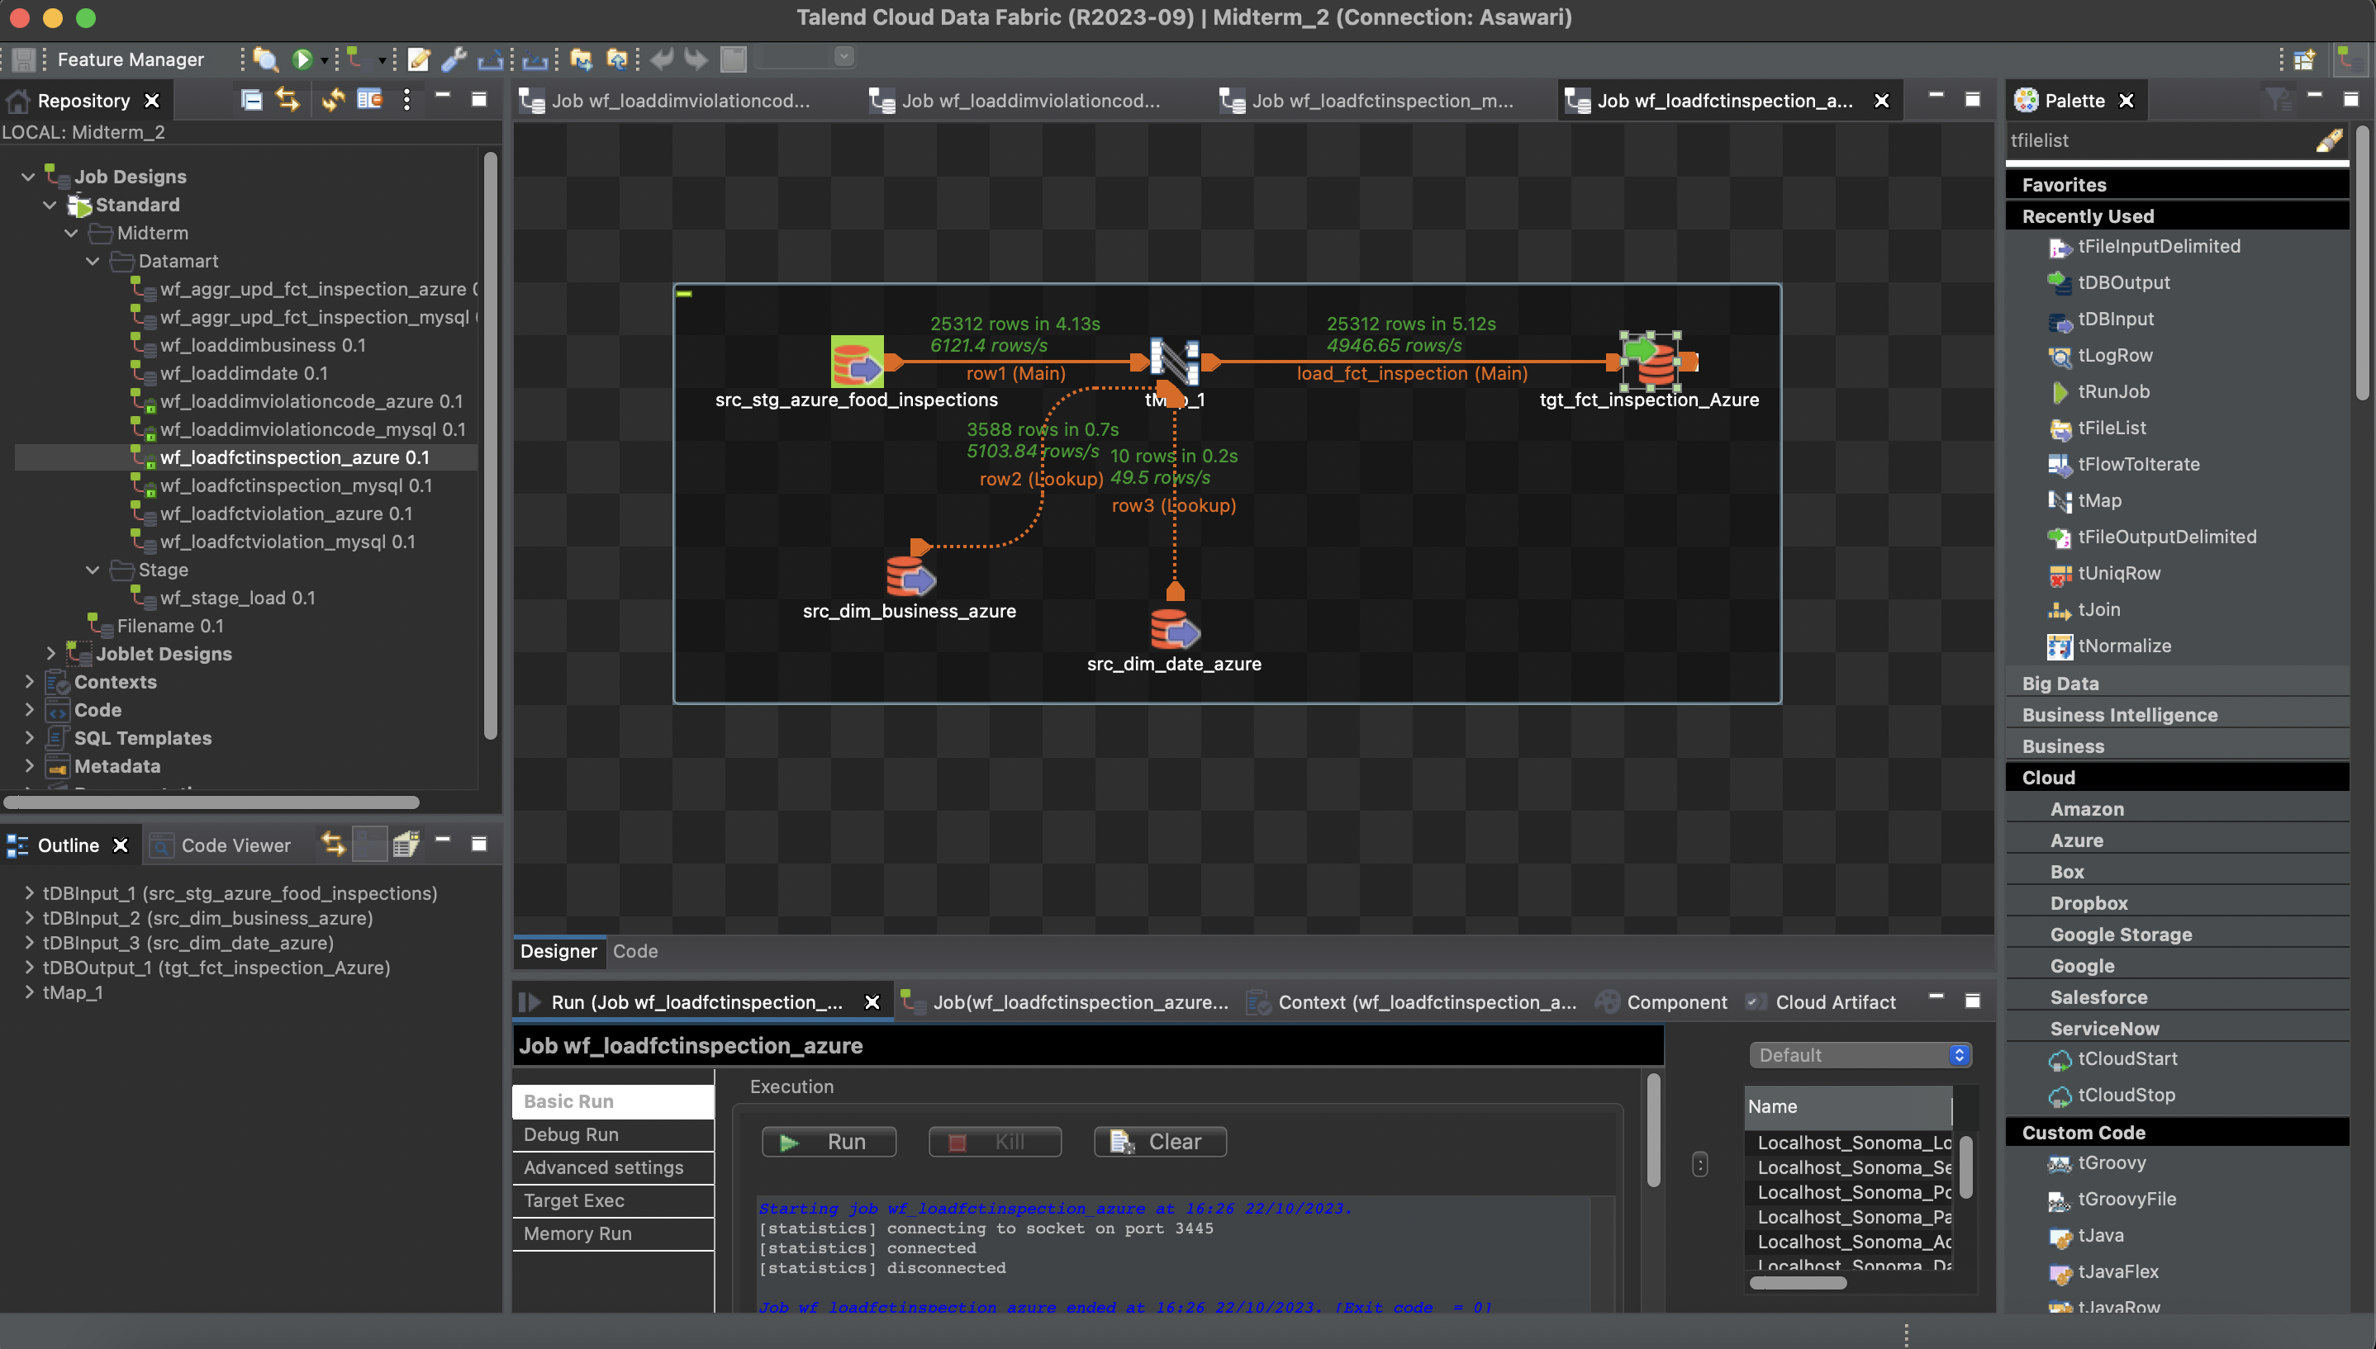

* Loading data to Fct_Violation

MySQL:

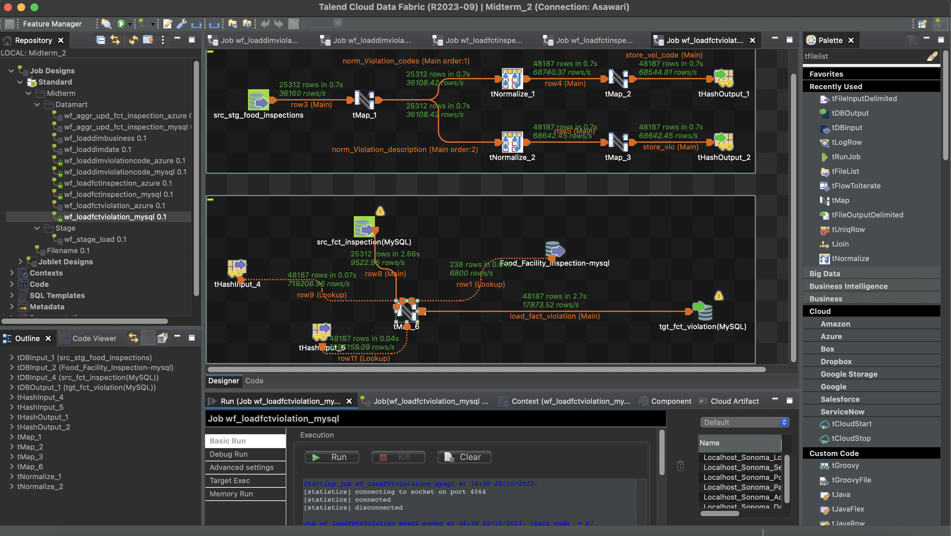

Azure SQL server:

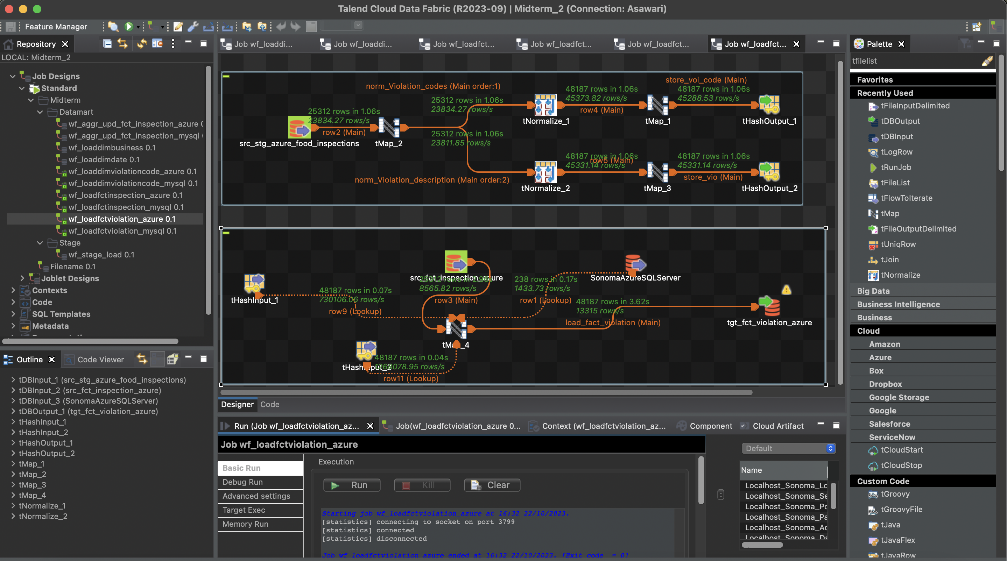

* Loading InspectionResult and aggregated violationScore into Fct_Inspection

MySQL:

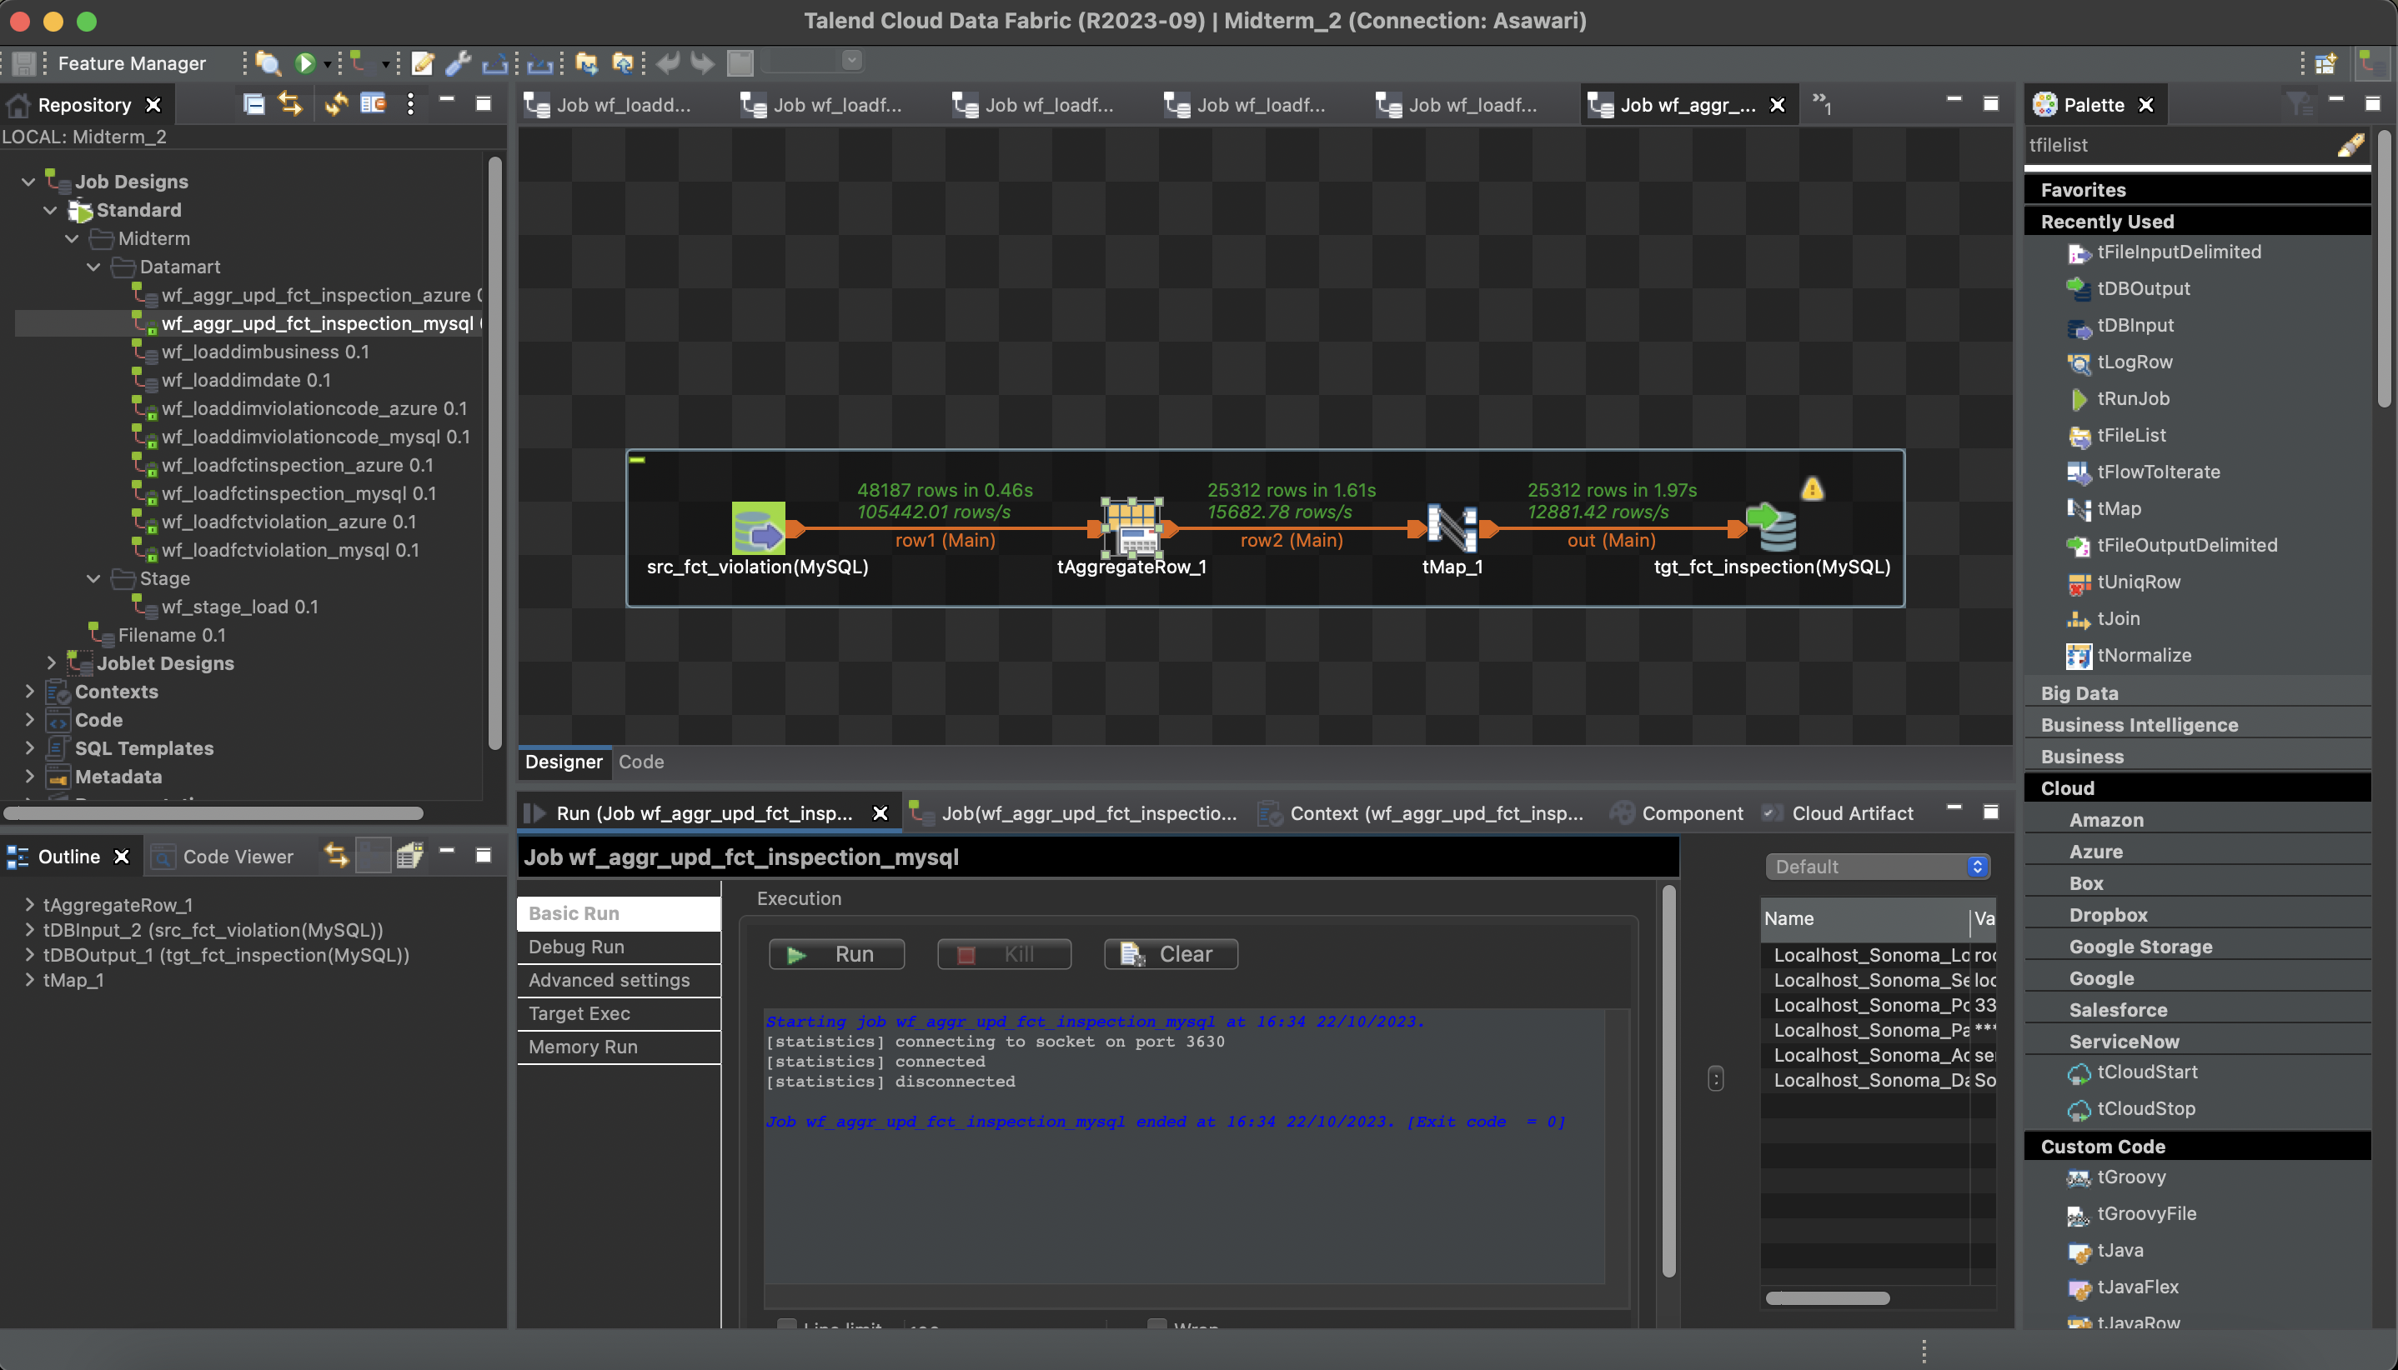

Azure SQL Server:

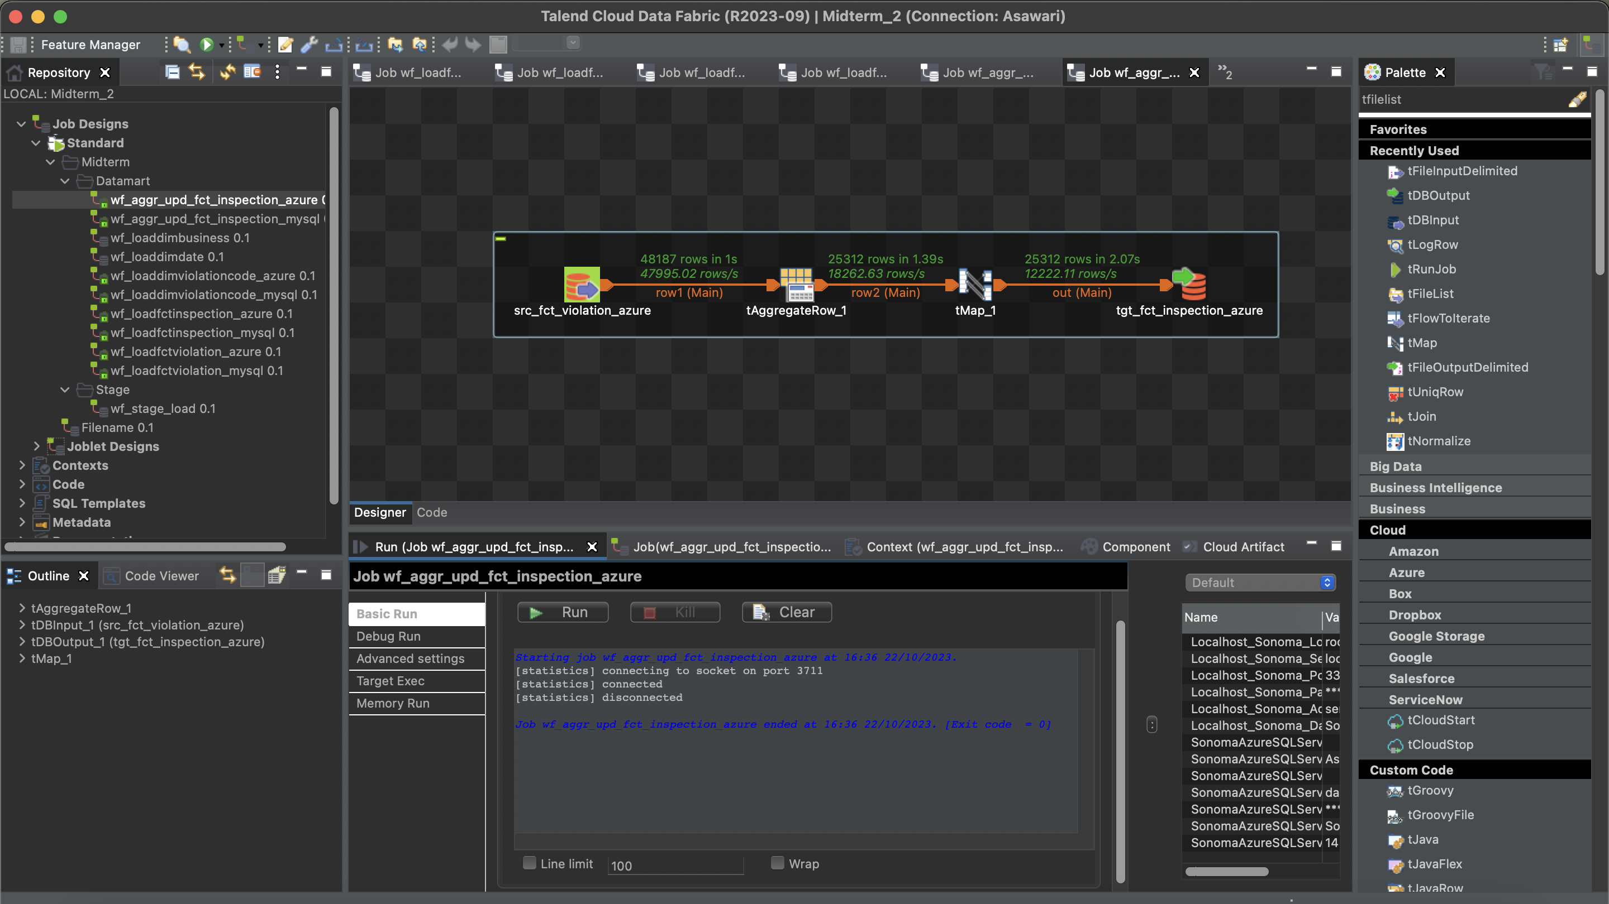

**Total count of each table**

* Staging table data

MySQL:

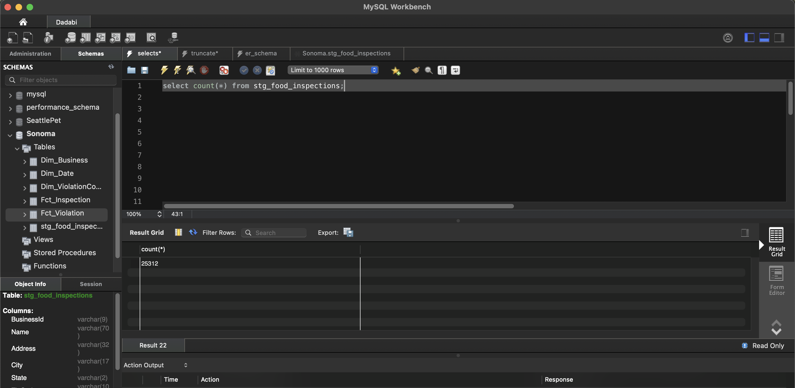

Azure SQL Server:

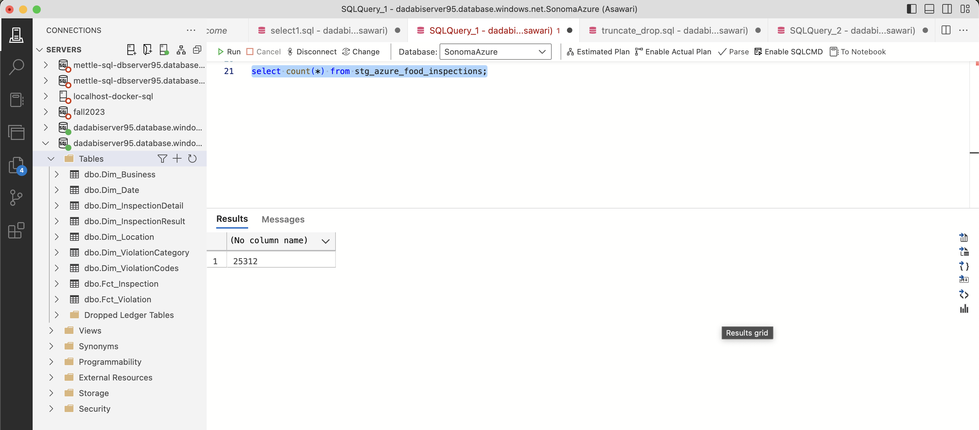

* Dim_Business

MySQL:

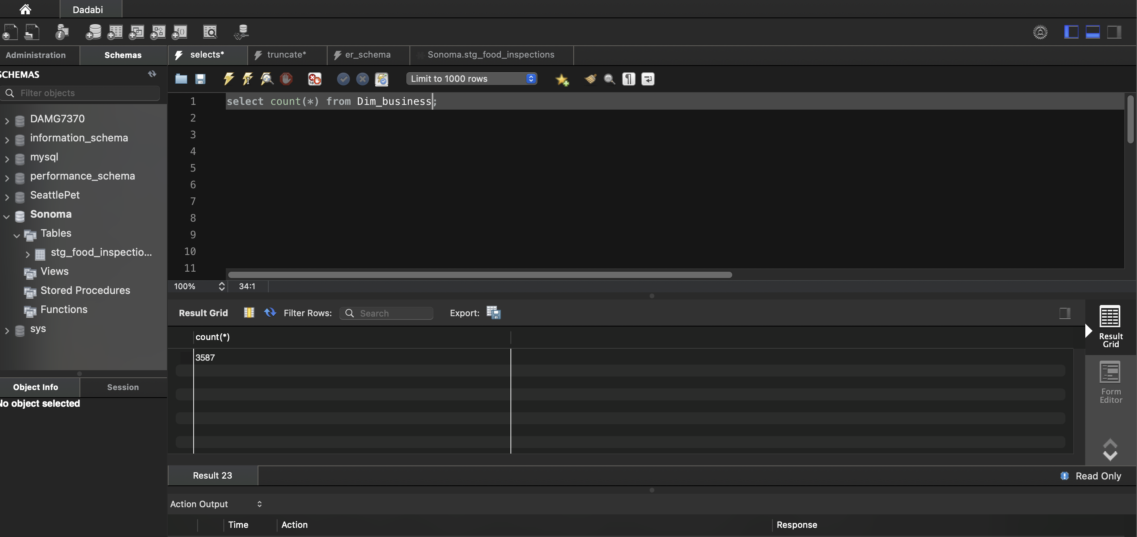

Azure SQL Server:

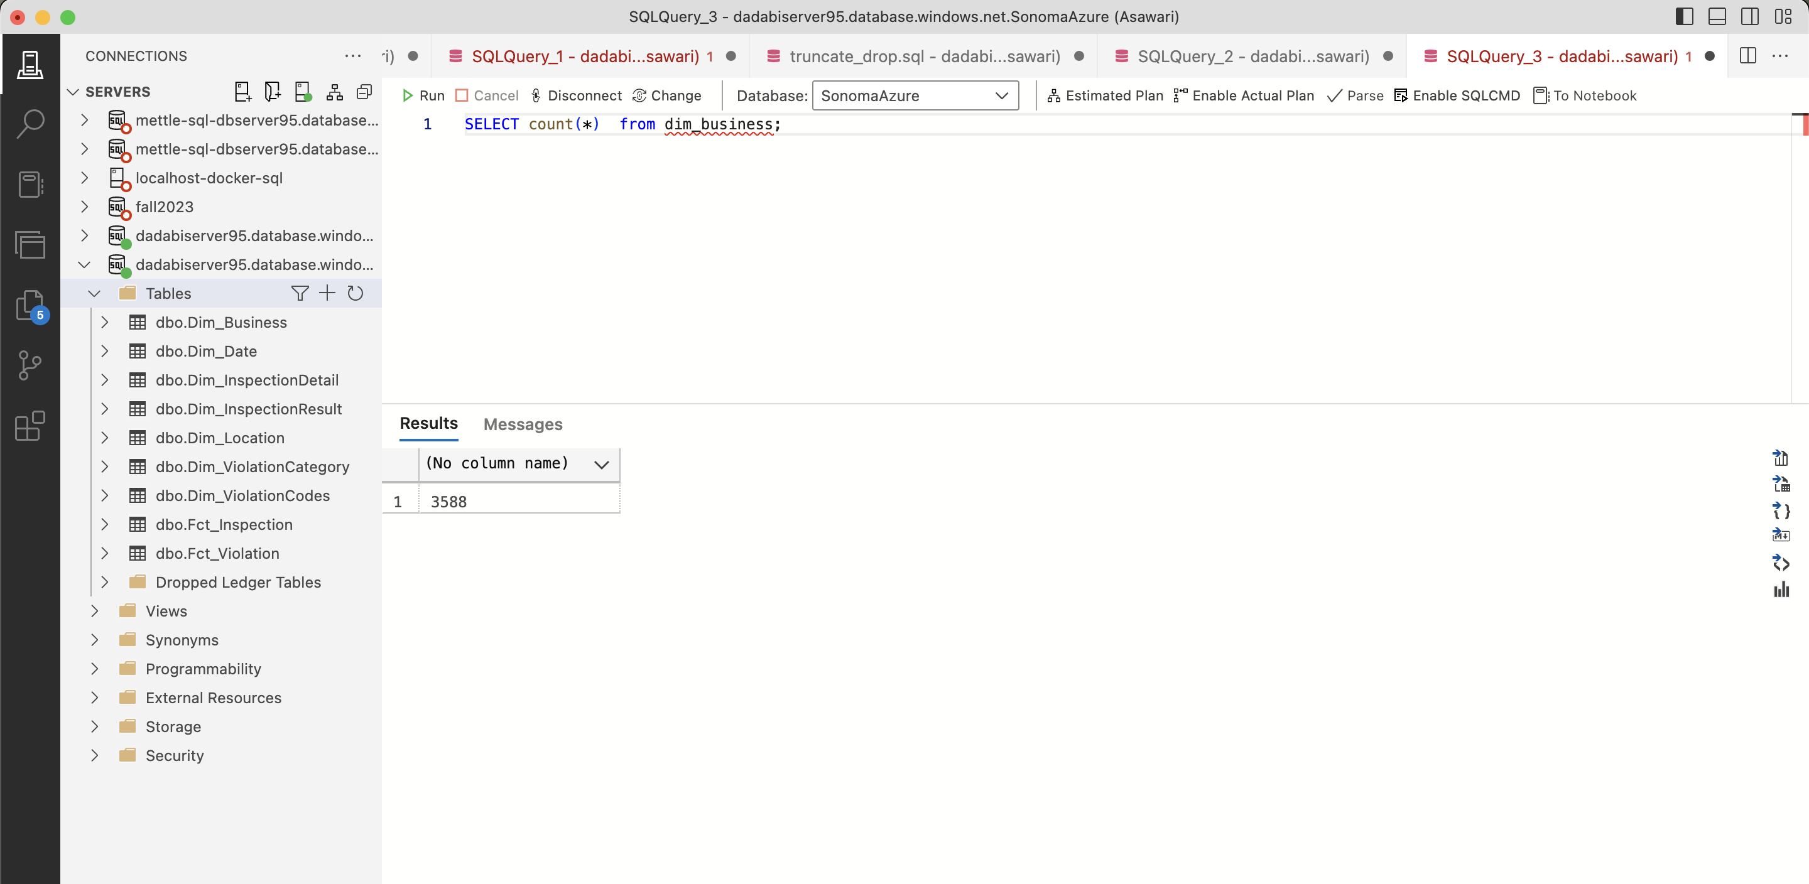

* Dim_Date

MySQL:

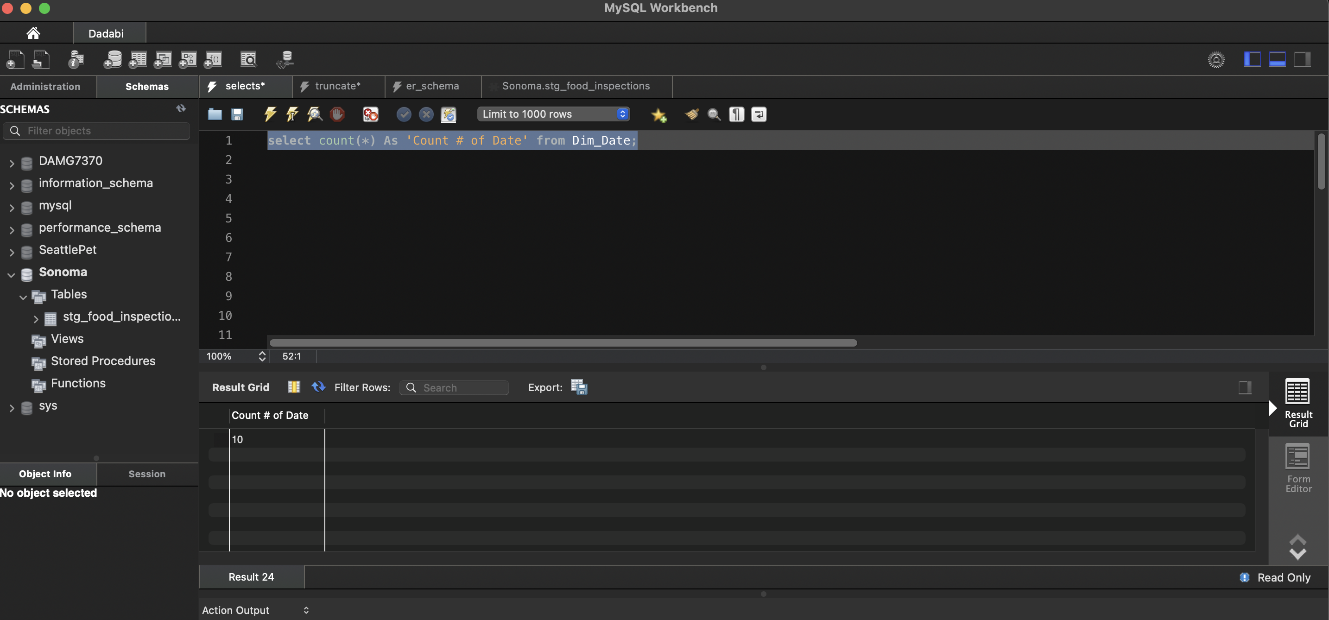

Azure SQL Server:

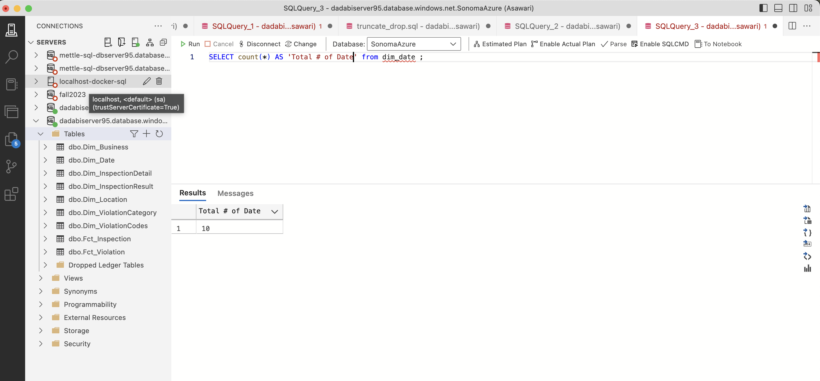

* Dim_ViolationCodes

MySQL:

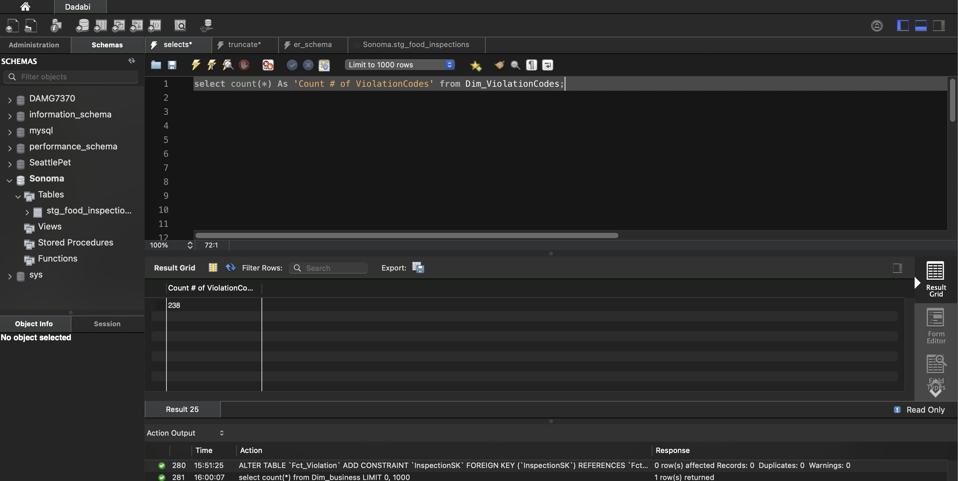

Azure SQL Server:

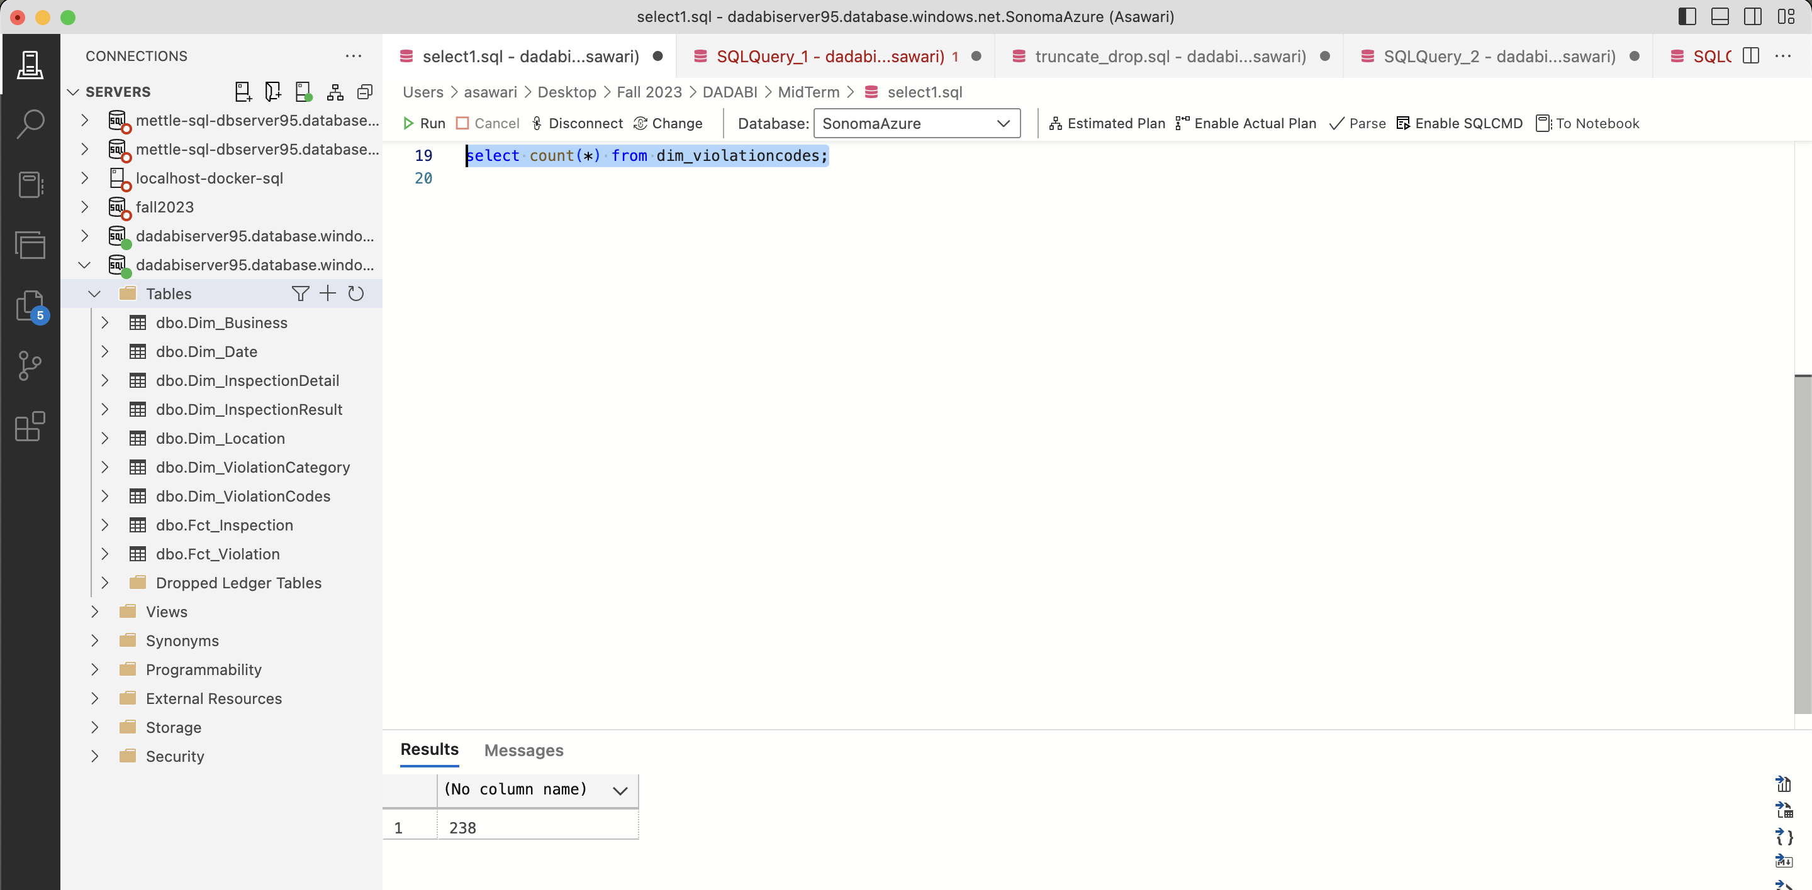

* Fct_Inpsection

MySQL:

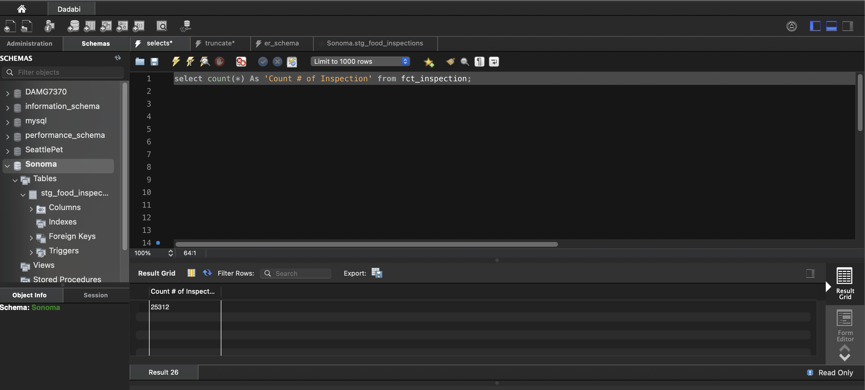

Azure SQL Server:

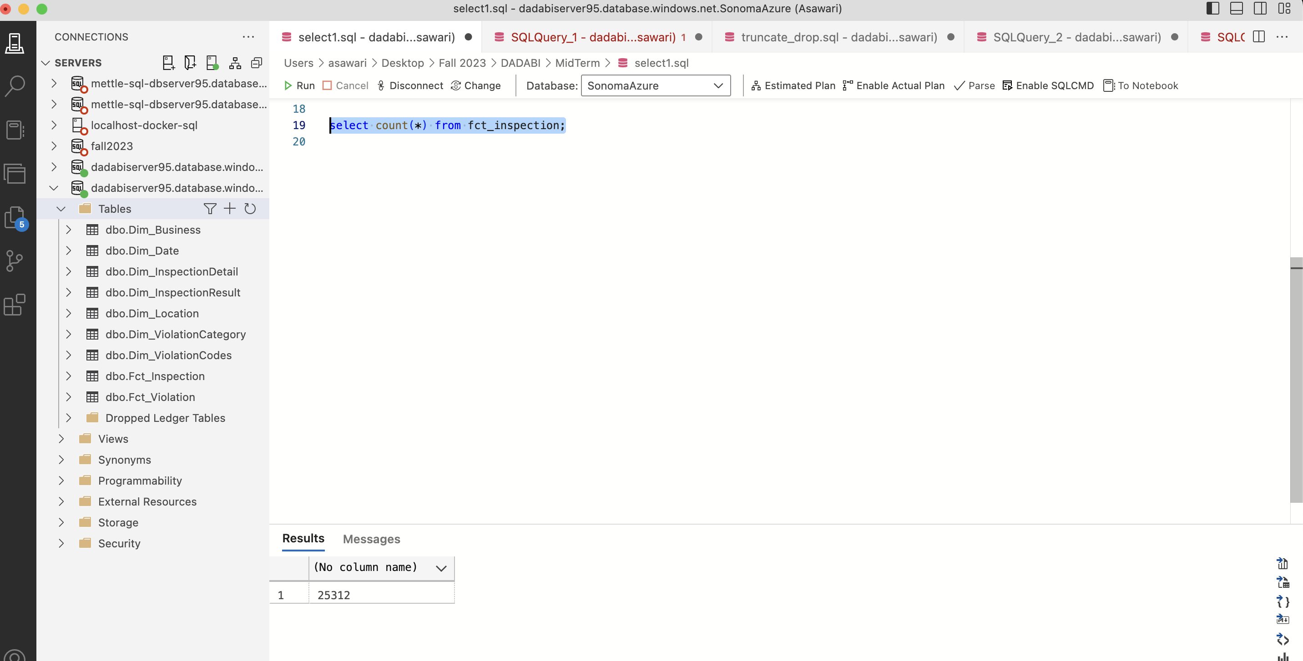

* Fct_Violation

MySQL:

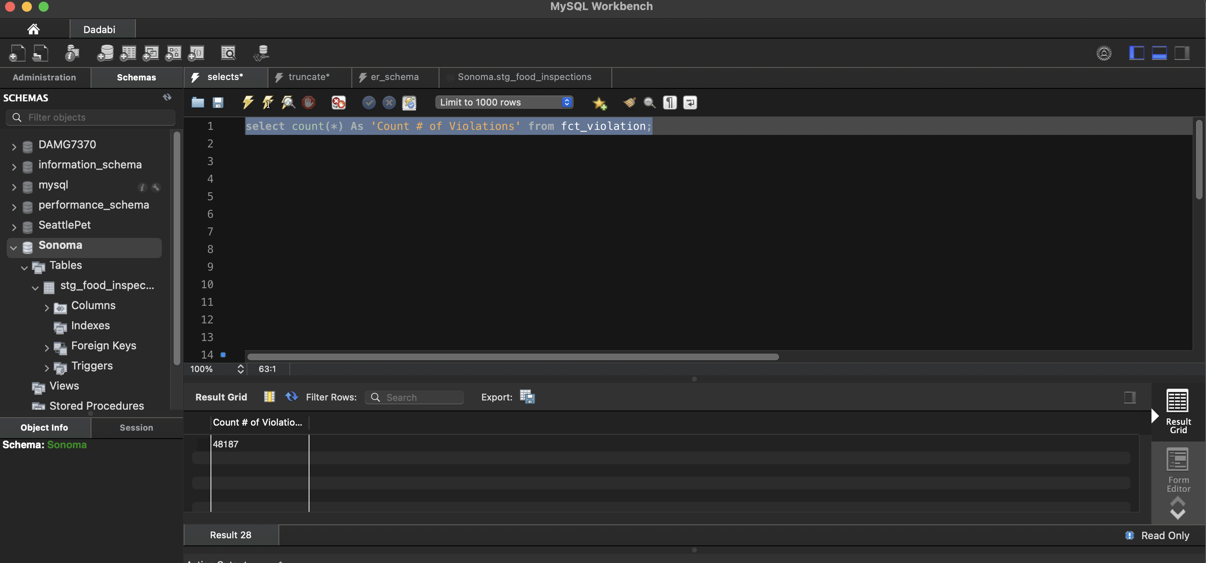

Azure SQL Server:

